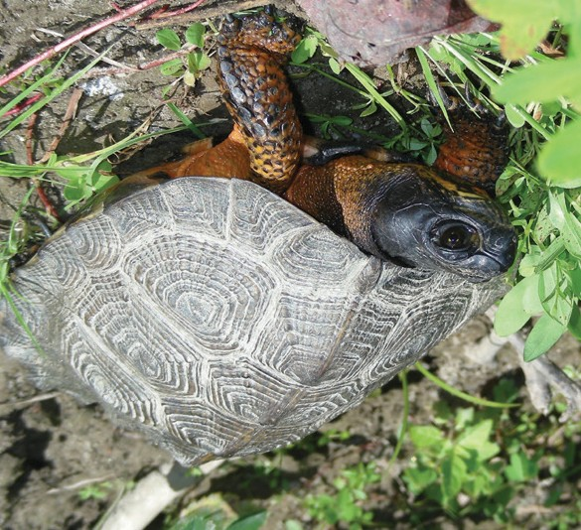
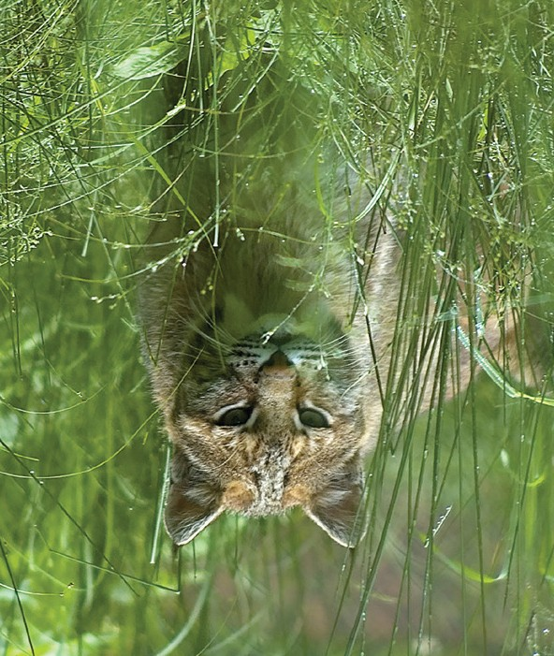

INSERT PARTNER LOGOS HERE

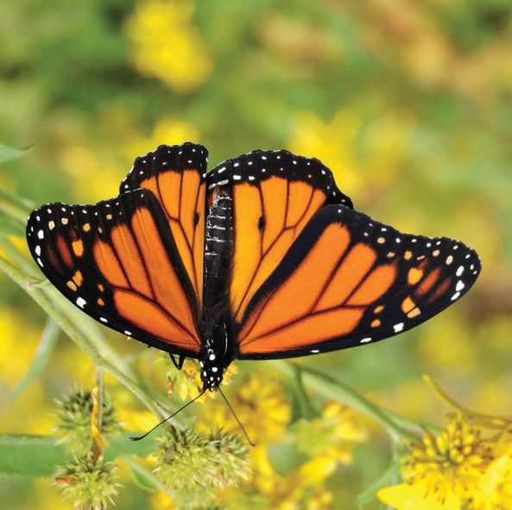
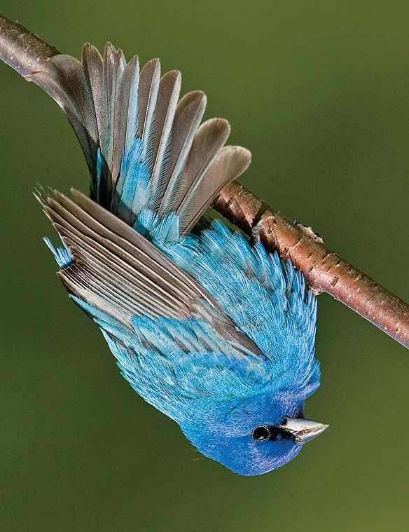
This rabbit needs you...
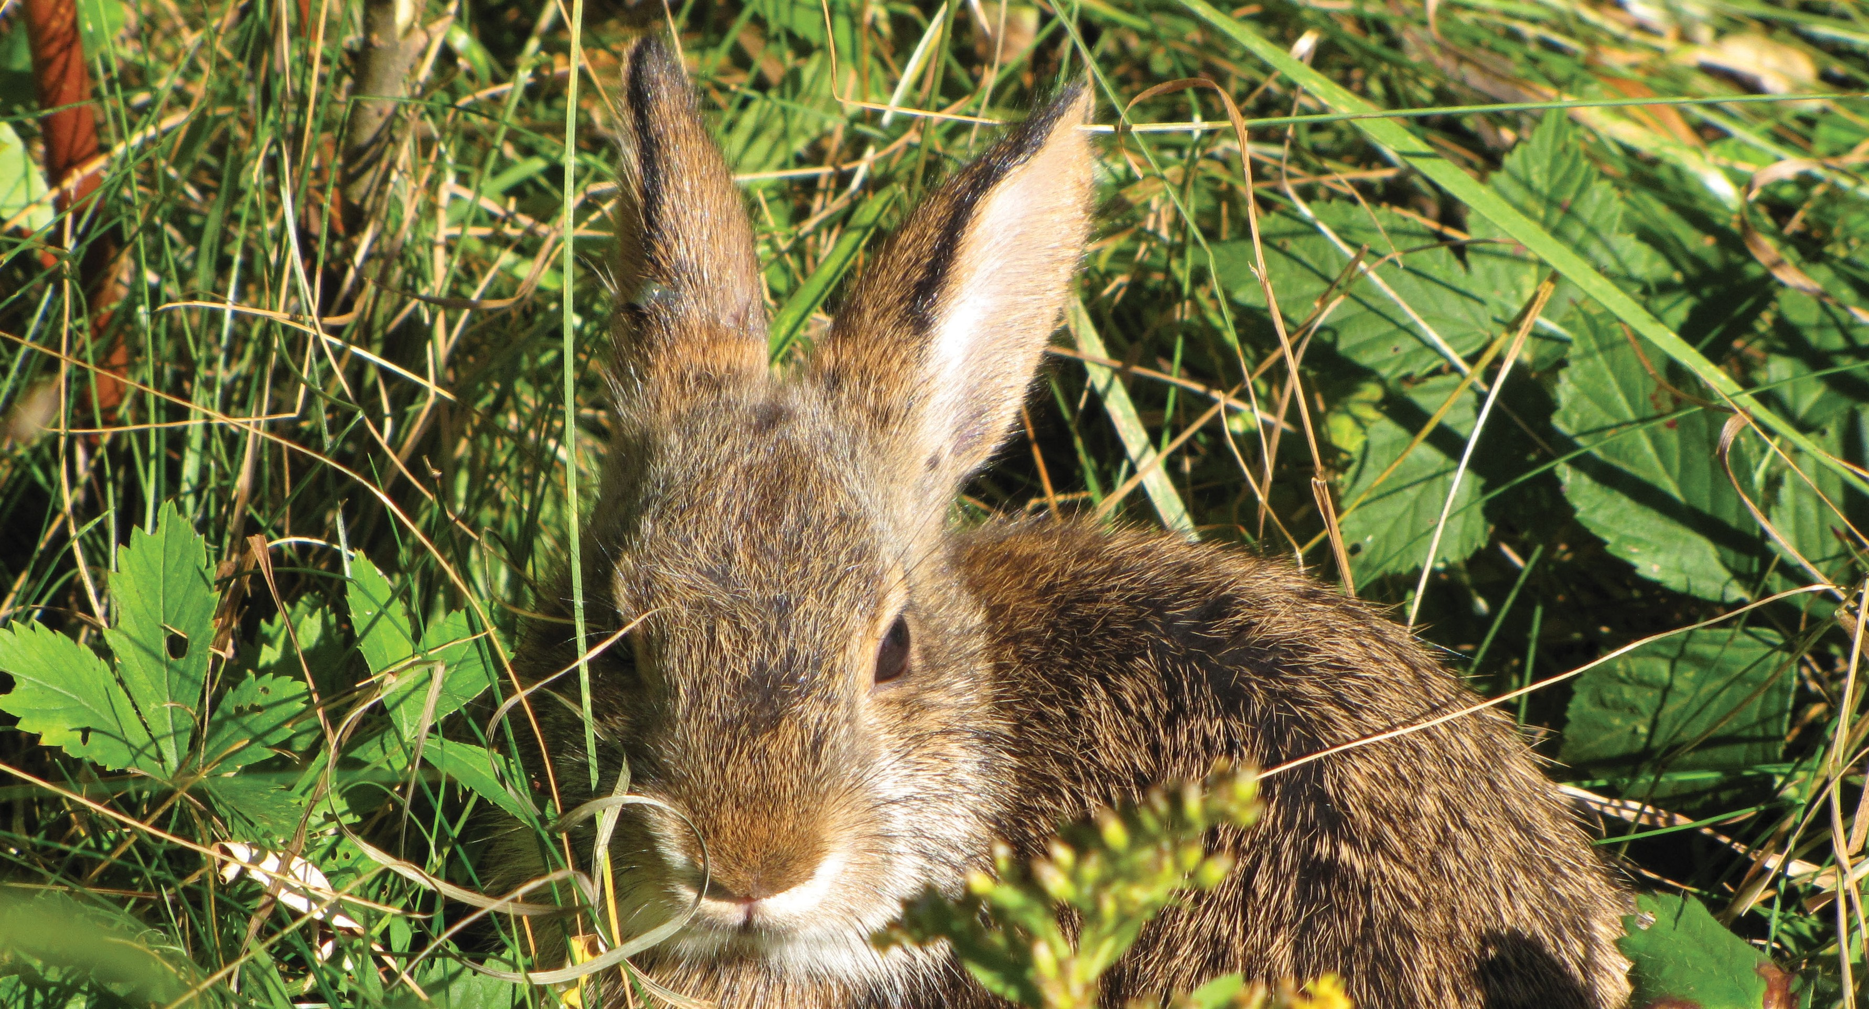

Have you ever taken action to save the rainforest?

Or worried about how ocean warming will affect marine life? Or considered planting native shrubs to provide food and shelter for birds? If so, you already know how important animals and plants are for keeping our world healthy and vibrant.

“As landowners, we are blessed to be stewards of this land. But it isn’t often that our actions directly affect the survival of one species, and the well-being of so many more. We are in a position to make a big difference. So let’s do it.”
- local landowner

Yet many plants and animals are under threat. This is happening every day and everywhere. But sometimes—when we’re lucky—smart, strategic actions by a few people can counter and reverse major losses.

You are one of those people whose actions can prevent the extinction of the New England Cottontail rabbit—the only rabbit native to New England.

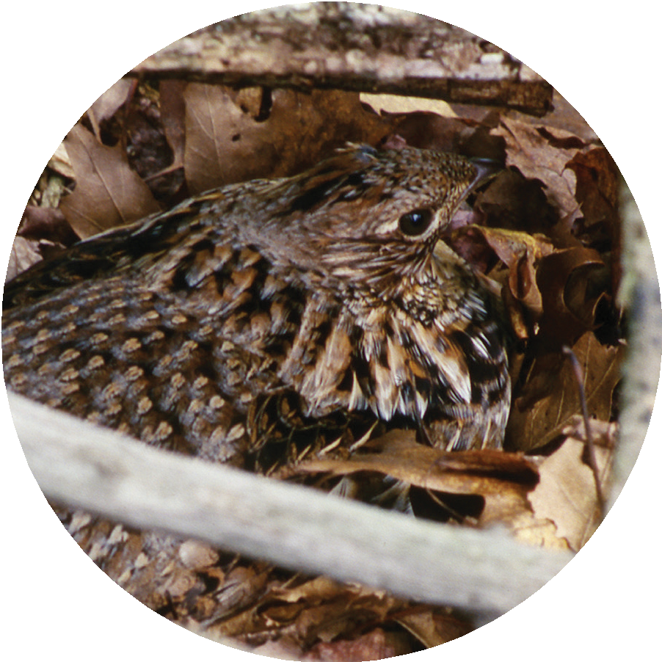
The New England Cottontail rabbit is
close to extinction because its habitat is dwindling. This rabbit needs young forest and shrublands, which are also important for more than 60 animals and birds, including [INSERT 2-3 CHARISMATIC SPECIES]. The New England Cottontail rabbit is just the first to be affected—the canary in a coal mine.

There are very few rabbit communities left in New England, and some of them are right here in [NAME] County. Every acre of habitat that we create here is a lifeline for this native rabbit and a godsend for many other types of animals and birds. That is why I am asking: Please consider creating cottontail habitat on your property.

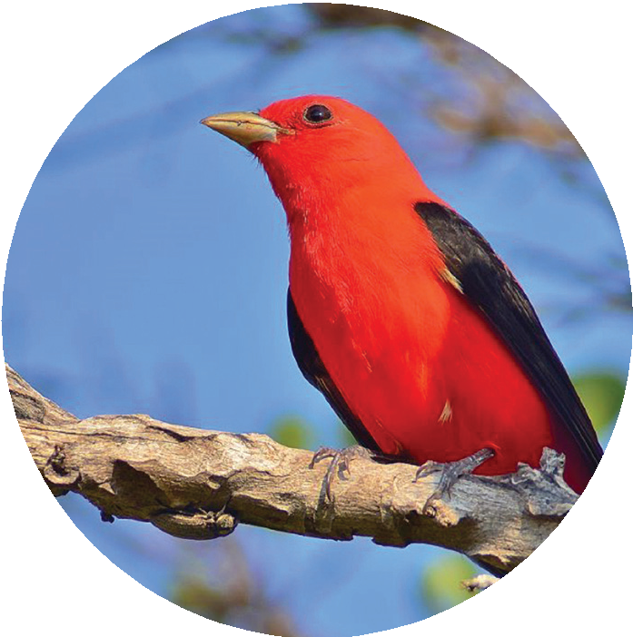
Special funds have been set aside for habitat creation on lands that are critically important for saving this rabbit. The [INSERT PROJECT NAME], a collaboration of conservation professionals, will help you use these funds to carry out a habitat creation project. We can design the project to improve the health of your woods and the recreational amenities on your property.

This project will likely cost you nothing, but it will make a big difference to many native animals and birds. Please contact [NAME] at [XXX-XXX-XXXX] or [EMAIL ADDRESS] to set up a time to talk. This call does not obligate you in any way; if you decide that a habitat project is not right for your property at this time, you will still have our thanks (and the rabbit’s) for considering this request.

[NAME]
[YOUR ORGANIZATION]
[CO-SIGNER]
[LOCAL LAND TRUST/CONSERVATION ORG]

FOR MORE INFORMATION ON THE [PROGRAM NAME], PLEASE VISIT [PROJECTWEBSITE.ORG]

